**Uses of Computer Networks:**

If nobody were interested in computer networks, few of them would be built. So let’s start with traditional uses at companies and for individuals and then move on to recent developments regarding mobile users and home networking.

1. **Business Applications**

* **Resource sharing:** the goal is to make all programs, equipment, and especially data available to anyone on the network without regard to the physical location of the resource and the user.
* **Server- client model:** One can imagine a company’s information system as consisting of one or more databases and some number of employees who need to access them remotely. In this model, the data are stored on powerful computers called **servers**. Often these are centrally housed and maintained by a system administrator. In contrast, the employees have simpler machines, called **clients**, on their desks, with which they access remote data, for example, to include in spreadsheets they are constructing.
* **Communication medium:** A computer network can provide a powerful communication medium among employees. Virtually every company that has two or more computers now has e-mail (electronic mail), which employees generally use for a great deal of daily communication.
* **E-Commerce:** A goal that is starting to become more important is doing business with consumers over the Internet. Airlines, bookstores and music vendors have discovered that many customers like the convenience of shopping from home. This sector is expected to grow quickly in the future. The most popular forms are listed in the below figure:

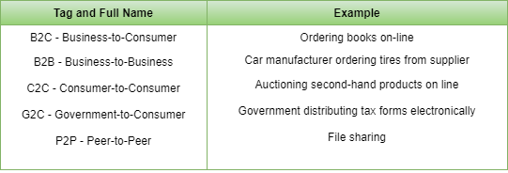

1. **Home Applications**: Some of the most important uses of the Internet for home users are as follows:

* Access to remote information
* Person-to-person communication
* Interactive entertainment
* Electronic Commerce

1. **Mobile Users:** Mobile computers, such as notebook computers and personal digital assistants (PDAs), are one of the fastest-growing segments of the computer industry.

Although wireless networking and mobile computing are often related, they are not identical, as the below figure shows.

